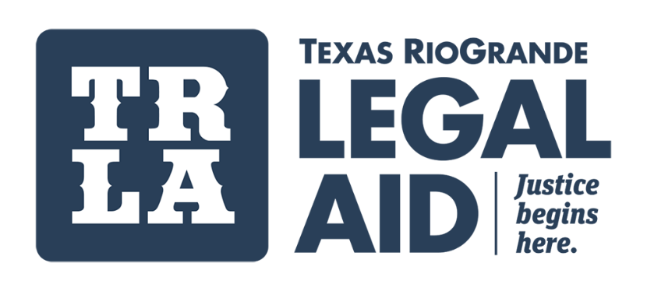

SAN ANTONIO
Address:
1111 N. Main Ave.
San Antonio, TX 78212

TRLA offices are closed for in-person visitation by the public. Except for some holidays, our phone line remains open on weekdays from 9:00 a.m. until 5:00 p.m. (Central Time). If you need legal assistance call: 956-996-TRLA (8752).

