DBM Project Referral Process

Go to www.sa-lsa.org/partnerintake and select “DBM Project” as your referring partner.
Click Continue.

Complete Applicant Information.

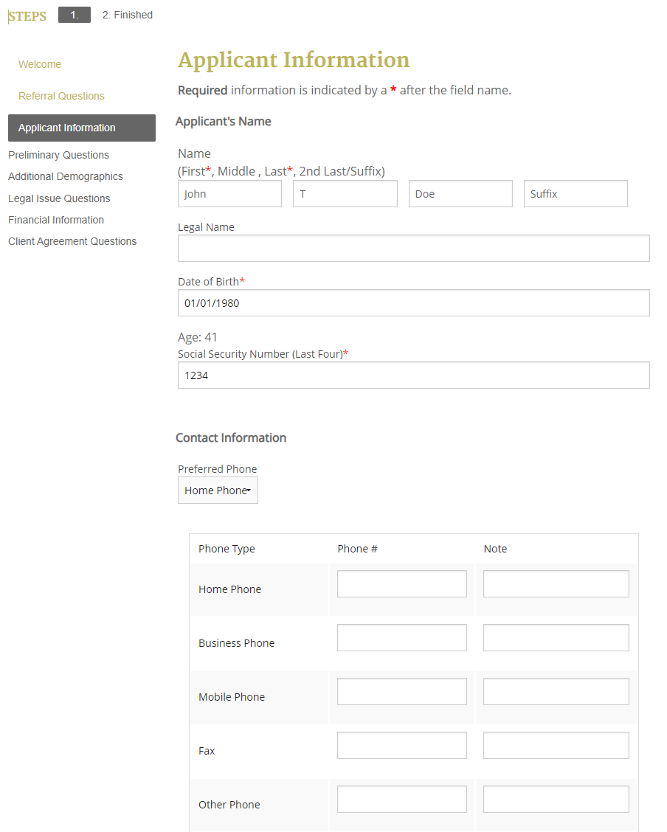

Click Continue.

Answer preliminary questions.

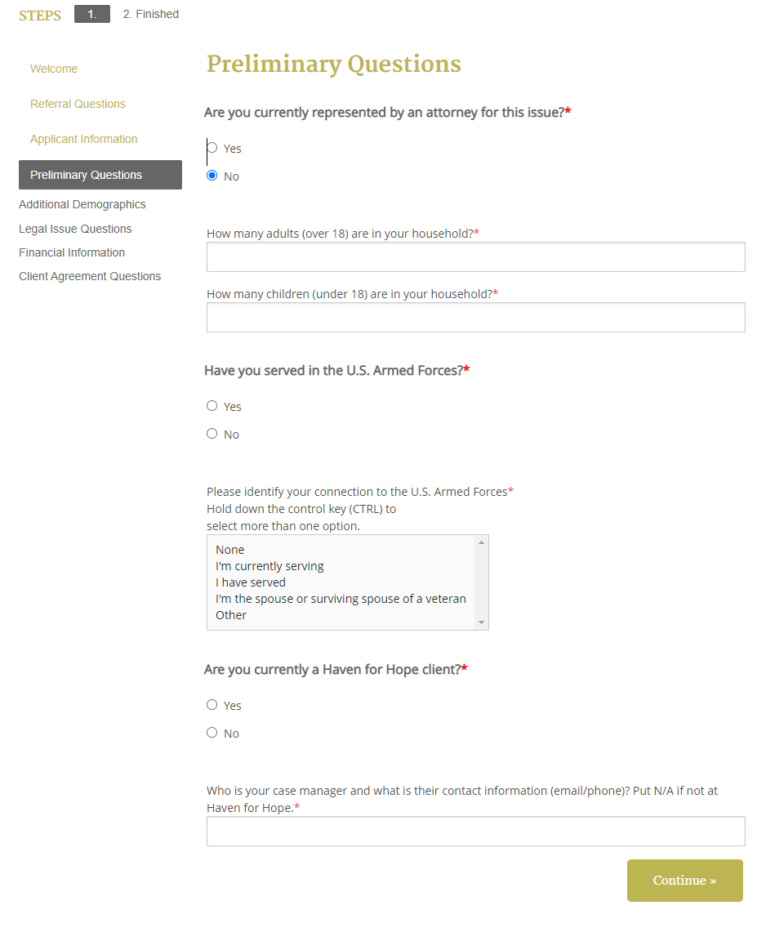
Click Continue.

Answer Additional Demographics Questions.

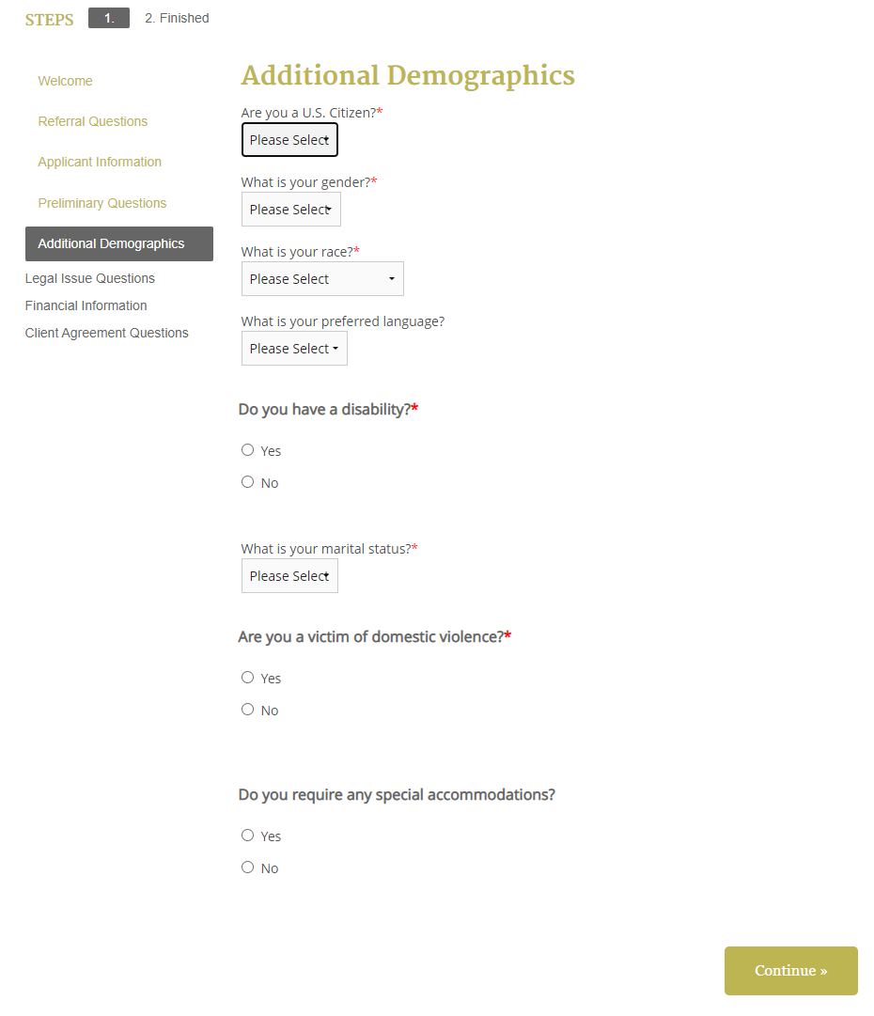

Click Continue.

In the “Briefly describe your legal issue” section, please copy and paste your notes from the intake interview. Be sure to include information about the bullying/cyberbullying and the goal(s) of the parent(s).

After selecting no for criminal assistance, select “Individual Rights” and “Bullying” as the legal problem.
Click Continue.

Enter Financial Information by TYPE of income using the drop-down menu.
NOTE: You must delete every line item that DOES NOT apply before clicking continue.

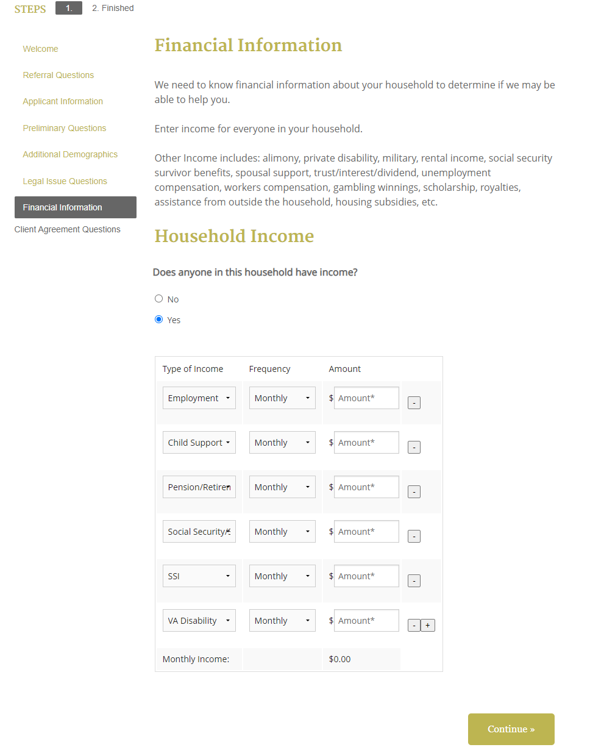
Click Continue.

Manually Complete Asset Assessment with Client
Create a list of all client assets. This includes cash or other resources of the applicant or members of the applicant’s household that are readily convertible to cash and are currently and available to the applicant.
SALSA’s Asset Policy is:
1) An individual seeking assistance may not have total family assets, disregarding exclusions more than the following: $10,000 plus $5,000 for each additional family member.
2) Exclusions: The household’s principal residence, vehicles used for transportation, assets used in producing income, and assets included in the list of assets which are exempt from attachment under State or Federal law are to be excluded in any asset determination.
Waiver: The Chief Executive Officer (CEO) may waive the ceilings on the above minimum-allowable assets in unusual or extremely meritorious situations. A waiver however must be in writing with sufficient facts to justify the request. Records of such waivers will be maintained to report on the number of applicants who receive assistance in this category. A specific form is available for staff that must be filled out and submitted to the CEO; and written approval must be obtained prior to the determination of eligibility and acceptance of an applicant’s case

Common Assets:
House
Car
Retirement Account
Personal Property

Things to Flag:
Note if each asset is jointly held or just held by the applicant.
Note if homestead.
Note if car is used for transportation.
Note if asset is used for producing income.
Note if there is a penalty for accessing the retirement account.
Ask client to estimate cost of personal property and include this as a lump sum amount.

This list should be emailed to dbmproject@sa-lsa.org after you submit the application.

Review Agreement with Client and get their verbal permission to submit their application for assistance.

Click Continue.

Application is now submitted for review.
Email asset information to dbmproject@sa-lsa.org

Submit Intake Closure Form at www.sa-lsa.org/dbmproject

