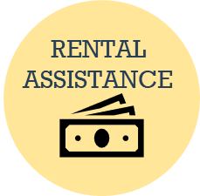
Needs rental or mortgage assistance, and:
San Antonio Eviction Checklist
- Hasn’t applied with the City of San Antonio have the client apply at:
  - https://dhs.mendixcloud.com/p/Kinetech/GovTech/HousingAssistance
- Already applied for City rental assistance call the Fair Housing Center at 210-207-5910 for a status update.

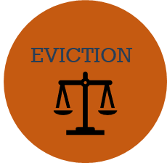
Property Covered by the CARES Act:
- Check out TRLA CARES Act Page to see if the property qualifies: https://www.trla.org/covid19-renter-protections-under-the-cares-act
  - If covered by CARES Act, landlords are prohibited from:
    - Filing evictions for non-payment of rent
    - Charging late fees or penalties for late payments of rent, for 120 days (March 27 – July 25, 2020).

Not covered by the CARES Act:
- Behind on rent Follow above Rental Assistance steps.
- Ch. 92 of the Texas Property Code covers residential tenancies
- Check local JP Court rules on court procedures, remote hearings, or whether the moratorium continues.
- Negotiate a Rule 11 with landlord to allow tenant to stay in the property, OR
- Negotiate with landlord for extra time to allow the tenant to find a new residence AND
- Negotiate with landlord for the eviction not to go on the tenant’s rental record.


Mobile Home Resident
- Covered by Ch. 94 of the Texas Property Code covers manufactured home tenancies

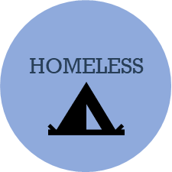
If Homeless:
- Send to San Antonio Homeless Hotline at (210) 207-1799

