Texas Bar Books
Forms

MS Word Reference Guide



Contents
Page
Installation 1
Introduction 1
Installation Using the Command File 1
Installation Bypassing the Command File 2
TBB Forms Ribbon 7
Instructions 7
Show Instructions 7
Hide Instructions 8
Next Instruction 8
Printable Instructions 9
Nonprintable Instructions 9
Delete Instructions 10
Restore Word Settings 10
Fill-In Prompts 11
Navigating to the Next Fill-In 11
Replacement Fill-In 11
Keep/Discard Fill-In 12
Select Option Fill-In 12
Complex Fill-Ins 13
Skipping Fill-Ins 14
Navigating Colons 14
Clause Selector 15
Using TBB Forms 16

Installation

Introduction
The Texas Bar Books toolbar is an MS Word macro template that provides tools to simplify completing forms included with many but not all Texas Bar Books digital products. The toolbar is compatible with Word on Windows systems only.
The toolbar must be manually installed on your computer. If your computer already has the toolbar installed from a previous digital download, there’s no need to reinstall it. That previous version should work for all Texas Bar Books products that are designed for use with the toolbar.
If the toolbar installed on your computer, you should see the “TBB Forms” tab on the ribbon at the top of your Word window.
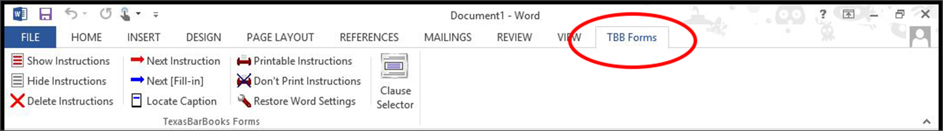
If only the “File,” “Tools,” and “View” tabs are visible, Word is in Read Mode. To see the complete set of tabs, including the “TBB Forms” one, switch Word to Edit Mode by selecting View > Edit Document.
Each digital download designed to use the toolbar should include toolbar manual-installation files. The same manual-installation files are available as a stand-alone version.

Installation Using the Command File
To install the toolbar using the included command (CMD) file, follow these instructions:

Close Word, if it’s open on your computer.

Using Windows Explorer or My Computer—

to install the toolbar from an already-downloaded and -installed digital download, navigate to the digital download’s subfolder named “Toolbar,” or

to install the toolbar from the stand-alone toolbar manual-installation file, navigate to the contents of that folder.

Inside the folder, double-click the “tbb-toolbar-install.cmd” file. You might see a black command prompt window quickly open and close.

Launch Word.

You should see the “TBB Forms” tab on the ribbon at the top of your Word window.

If only the “File,” “Tools,” and “View” tabs are visible, Word is in Read Mode. To see the complete set of tabs, including the “TBB Forms” one, switch Word to Edit Mode by selecting View > Edit Document.

Installation Bypassing the Command File
If the “TBB Forms” tab does not appear when you first relaunch Word after double-clicking the command file, even with Word in Edit Mode, most likely your Word Startup folder is not in its default location. It may have been moved by a user or another program. To solve this problem, follow the steps below to copy the “TBB Forms.dotm” file into it.

Using Windows Explorer or My Computer—

for an already-downloaded and -installed digital download, navigate to the digital download’s subfolder named “Toolbar,” or

for the stand-alone toolbar manual-installation file, navigate to the contents of that folder.

Open the “word-templates” folder.

Single-click (highlight) the “TBB Forms.dotm” file. Select “Copy” from the menu (or press Ctrl + C on your keyboard).
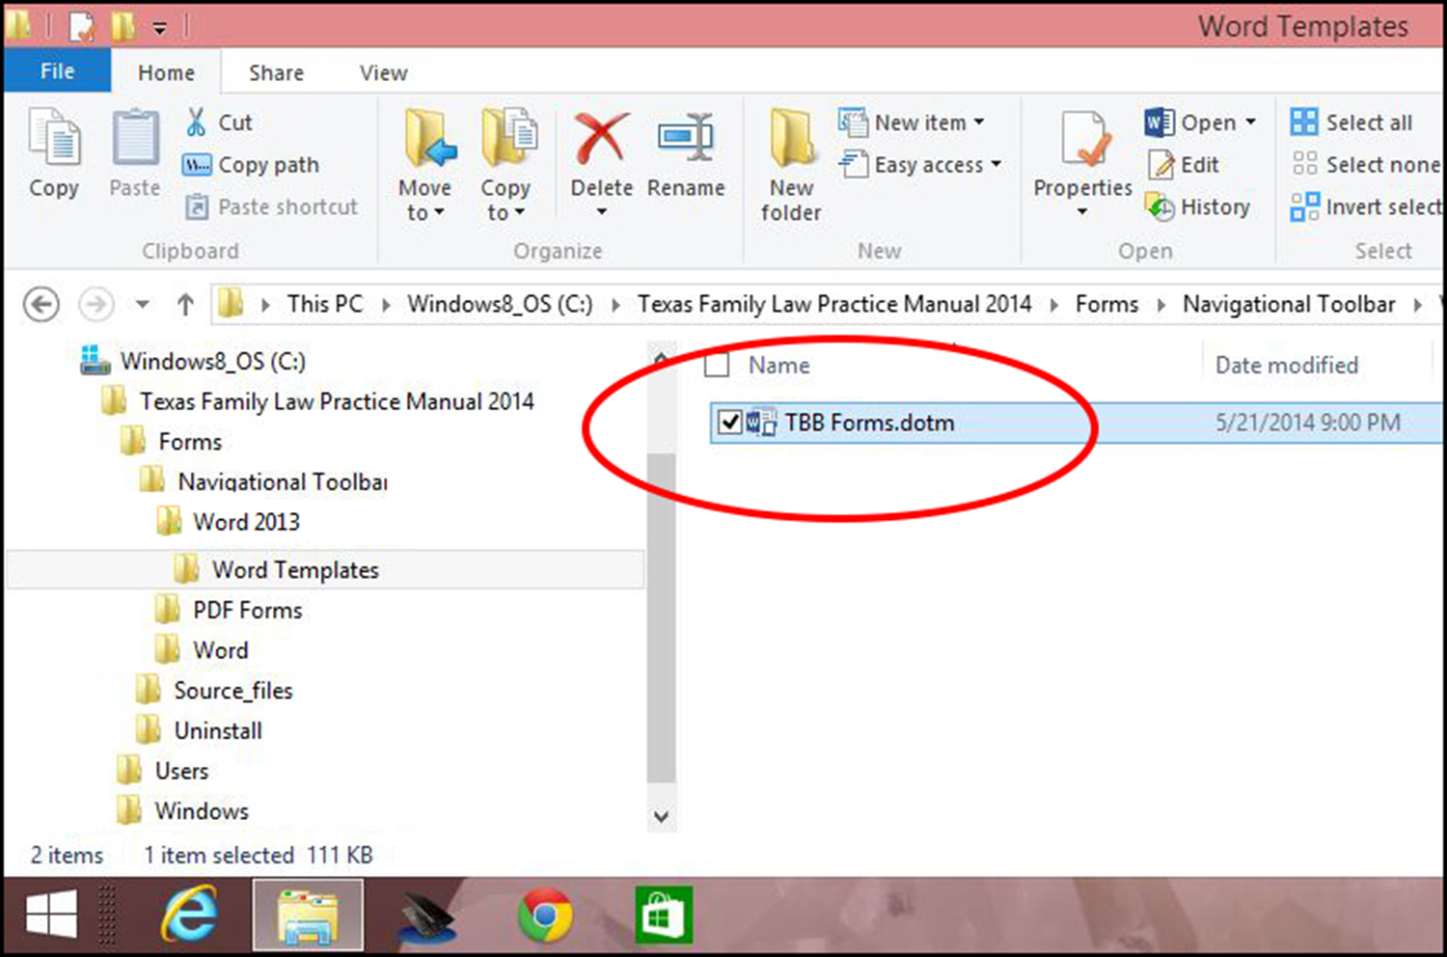

If Word is not open on your computer, launch Word.

From the menu bar, select “File.”

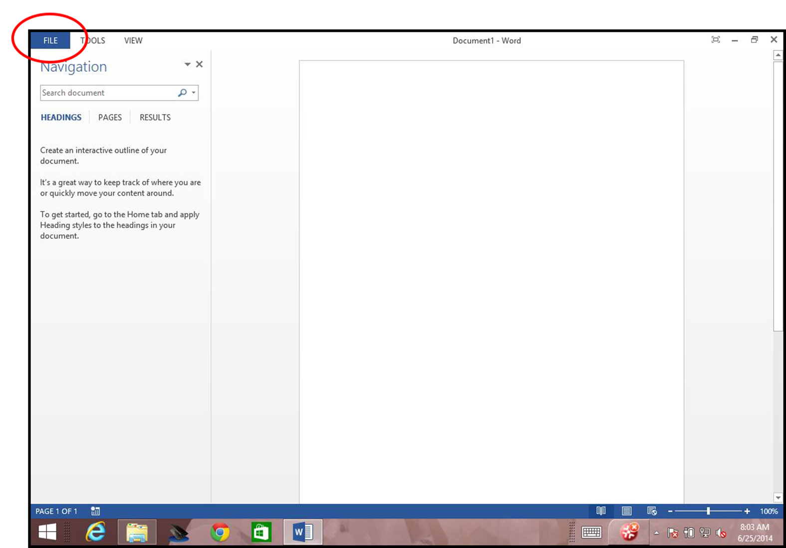

In the menu that appears on the left side of the window, select “Options.”
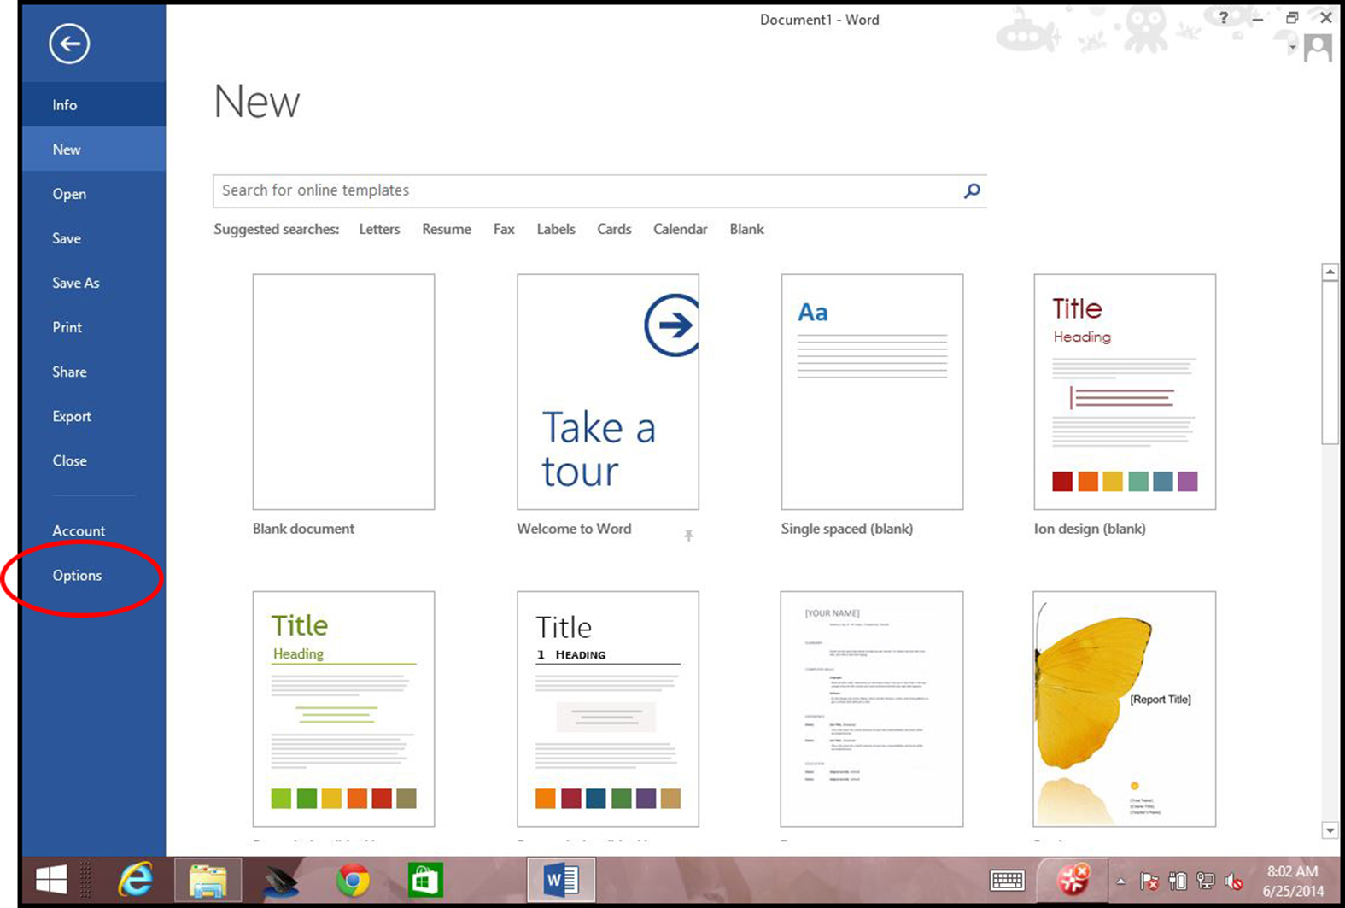

The “Word Options” window should open. In the menu in the left pane of that window, select “Advanced.”
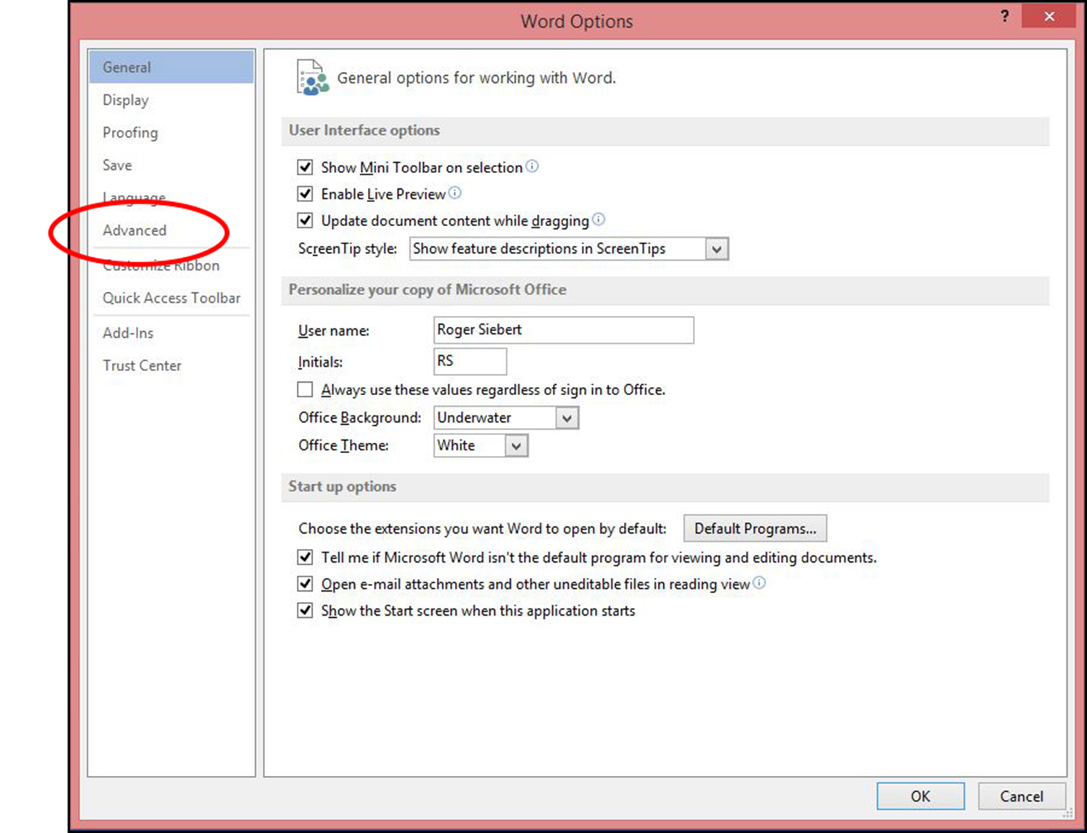

In the advanced options that appear in the right pane of the “Word Options” window, scroll down to the very bottom and click the “File Locations…” button.
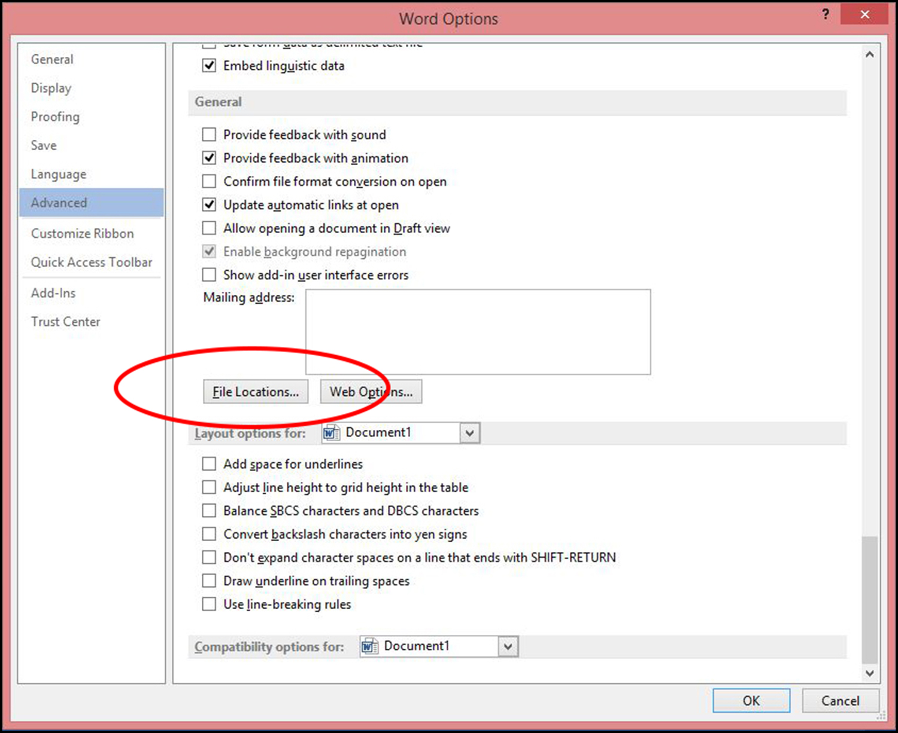

In the “File Locations” window that opens, double-click the “Startup” file location.
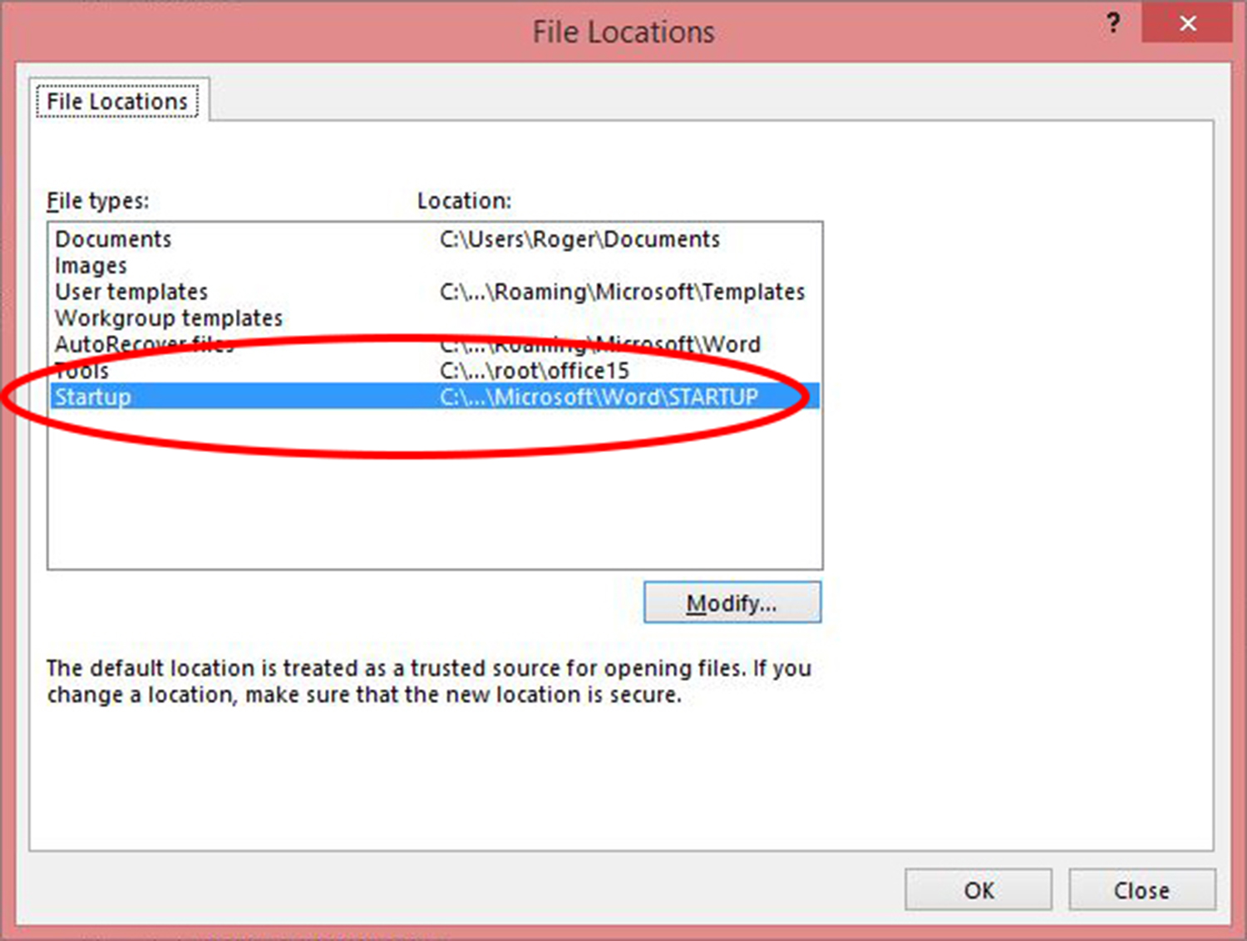

In the “Modify Location” window that opens, click “Organize,” and in the options that appear, select “Paste.”

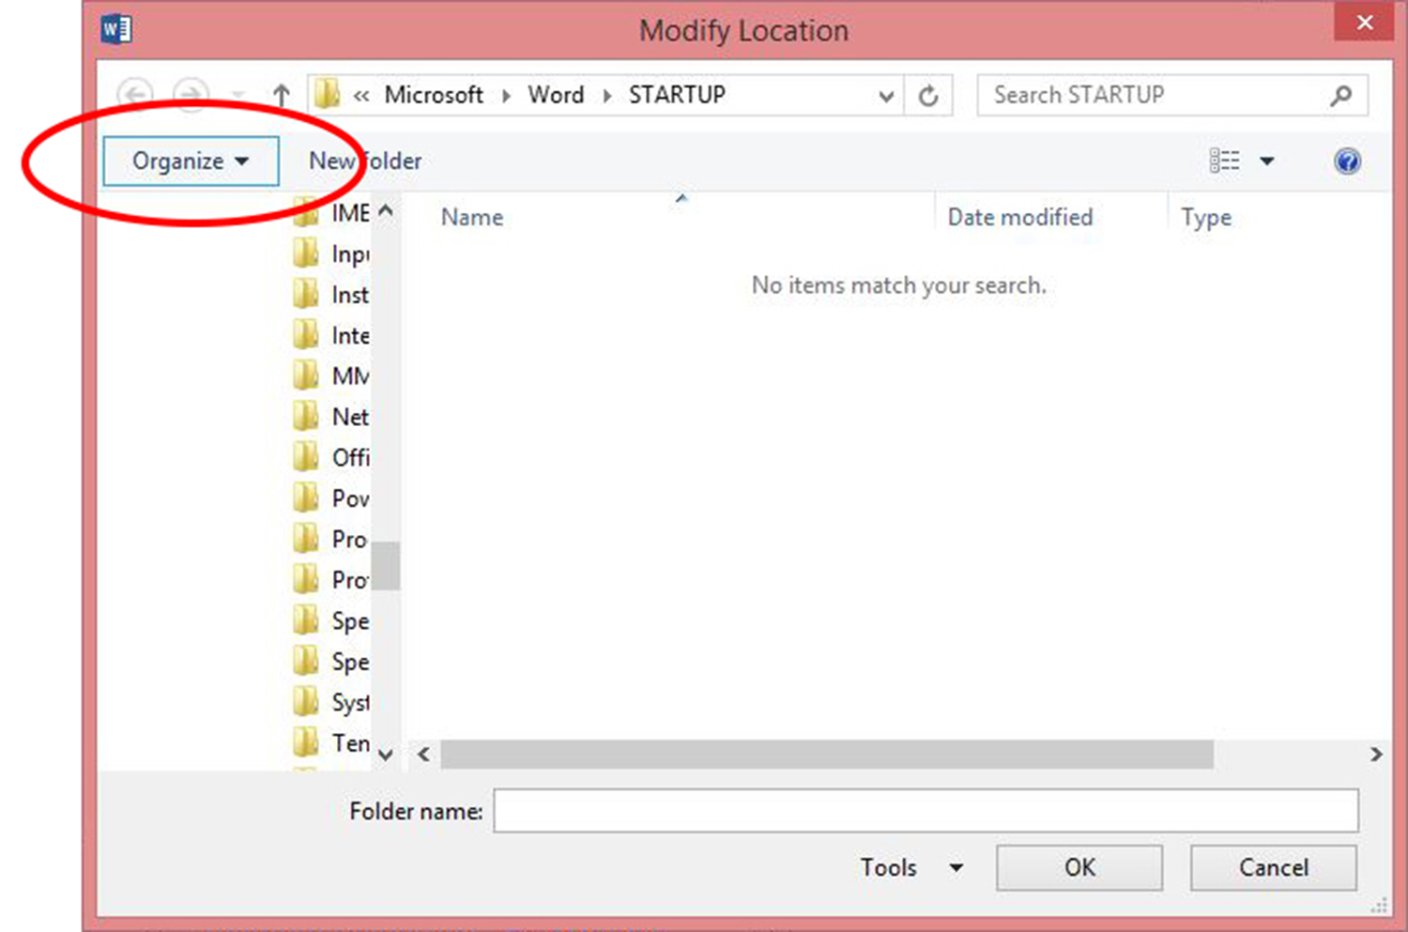

Close all open windows by selecting “Cancel” or “Close” as appropriate, and close and relaunch Word. You should see the “TBB Forms” tab on the ribbon at the top of your Word window.

If only the “File,” “Tools,” and “View” tabs are visible, Word is in Read Mode. To see the complete set of tabs, including the “TBB Forms” one, switch Word to Edit Mode by selecting View > Edit Document.

TBB Forms Ribbon
Once the TBB Forms template is properly installed, you will see the TBB Forms tab on the Word ribbon. The TBB Forms ribbon provides access to tools that help you navigate, complete, and manage the forms.
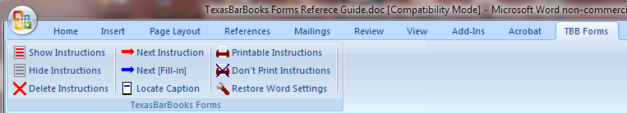

Instructions
The TBB Forms include instructions that guide you on information that is needed in the forms. Instruction text is formatted with red font to make it easy to discern from the rest of the document. The instructions are for your information and are not text that you would include in a finished form, so they are also formatted as hidden text to make it easy to show and hide them in any document.

Show Instructions
All forms include some instructions. If you do not see instructions when you open a form, you can display them with the Show Instructions tool.

To show instructions in a TBB form:
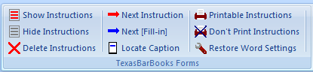

From within the form, choose TBB FormsShow Instructions.
The instructions display in the document.
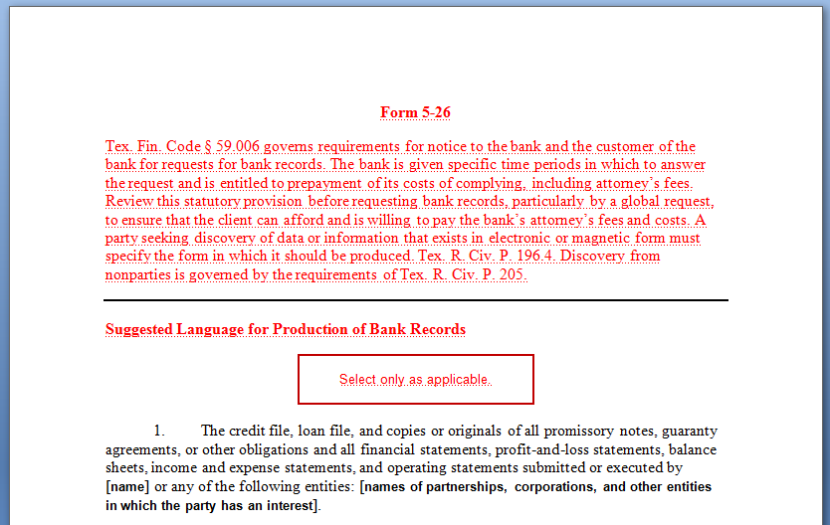
All red text that displays when Show Instructions is used are instruction paragraphs.

Hide Instructions
Use the Hide Instructions tool to view the final version of the form without actually deleting the instructions.

To Hide Instructions in a Form:

From within the form, choose TBB FormsHide Instructions.
The instructions no longer display in the document.
When Hide Instructions is used, hidden text does not display, so while the instructions are still in the document, they do not show.
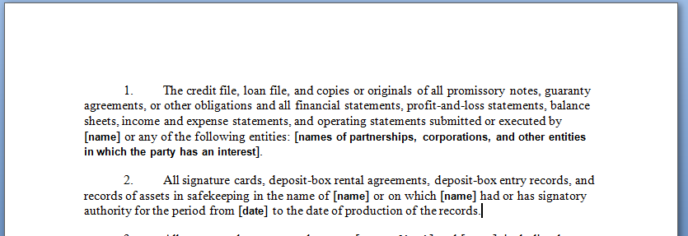

Next Instruction
Use the Next Instruction tool to navigate to the next instruction in a form.

To move to the next instruction in a form:

(If necessary) Choose Show Instructions so instructions are visible.

Click Next Instruction.
The insertion point takes you to the next instruction. If there are not more instructions past the current insertion point, the below prompt appears.
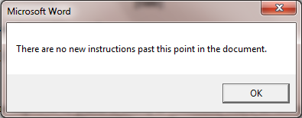

Printable Instructions
By default, hidden text does not print in Word. So even if you are showing the instructions on screen, they will not be included in a printout unless Word is set to print hidden text.
Use the Printable Instructions setting to tell Word to print hidden text.

To print the instructions with the form:

Choose TBB FormsPrintable Instructions.
The Word setting to print hidden text activates and the instructions (and all other hidden text) will print.

Note:
Once you set hidden text to print, hidden text will continue to print for all documents until you turn that setting off.

Nonprintable Instructions
Use the Don’t Print Instructions tool to tell Word to no longer print hidden text.

To turn off the print hidden text feature:

Choose TBB FormsDon’t Print Instructions.
The instructions will not be included in form printouts.

Delete Instructions
When you have completed working on a form you may want to delete the instructions from the form, especially if you intend to e-mail it to someone. The Delete Instructions tool removes all paragraphs formatted with the Instructions styles from the document.

To delete instructions from a form:

From within the form, choose TBB FormsDelete Instructions.

Caution:
Once you have deleted instructions and saved a form, you cannot get them back in that document. You can, however, always retrieve a fresh copy of the form from your original set of the form files.

Restore Word Settings
The Show Instructions and Printable Instructions tools alter Word’s default settings to not print and not show hidden text. Consequently, after you’ve used those tools you may find hidden text showing or printing when you don’t want it to. Use the Restore Word Settings tool to restore both these settings to the Word default.

To restore Word settings:

From within the form, choose TBB FormsRestore Word Settings.
Hidden text is set to not print and only show when Word’s show/hide feature is activated.

Fill-In Prompts
The bracketed text in the forms is there to be filled in by the attorney completing the form
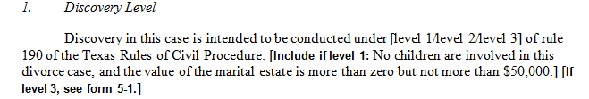

Navigating to the Next Fill-In
The bracketed fill-in text falls into the four fill-in types described below. Use the Next [Fill-in] tool to navigate to the next set of bracketed text.

To navigate to the next fill-in:

Choose TBB FormsNext [Fill-in].
The insertion point moves to the next fill-in. You are presented options based on the type of fill-in it finds.

Replacement Fill-In
Bracketed text that has bold-faced Arial font is designed to be replaced. When the Next [Fill-in] tool locates one of these fill-ins, it selects the text so you can type to replace it.

To complete a replacement fill-in:

When the Next [Fill-in] tool selects the fill-in, type the desired text to replace the fill-in.

You do not need to delete selected text first; typing replaces what is selected.
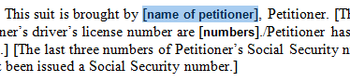

Keep/Discard Fill-In
Some bracketed text is designed to be kept or discarded.

To complete a Keep/Discard fill-in:

When the Next [Fill-in] tool stops at the fill-in, the bracketed text is displayed in a dialog box. Perform one of the following actions:
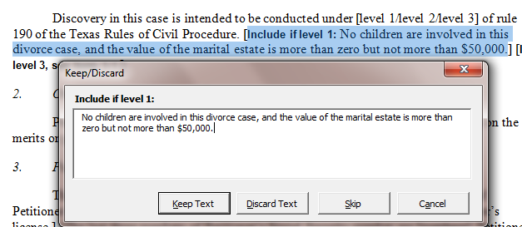

Choose Keep Text:
The text will be kept in the form without the brackets or any introductory text (like the “Include if level 1” in the example above). If the kept text contains a sublevel bracketed fill-in, the Next [Fill-in] tool will automatically move to it.

Note:
If necessary, you can alter text in a Keep/Discard text box. When you do this the original fill-in is replaced with the text you specified, and any formatting (such as bold/Arial) on a sublevel bracketed fill-in is lost.

Choose Discard Text:
The entire fill-in is deleted.

Choose Skip:
The fill-in is left in its original state and the insertion point moves past it in the document. You can use the Next [Fill-in] tool to return to this fill-in later if you wish.

Choose Cancel:
The entire process is cancelled and the insertion point remains where it was before you ran the Next [Fill-in] tool.

Select Option Fill-In
Some bracketed text contains slashes that divide text into options. The Select Option(s) dialog box will typically appear for this type of fill-in. Usually you will just want one option, but occasionally multiple choices are appropriate.
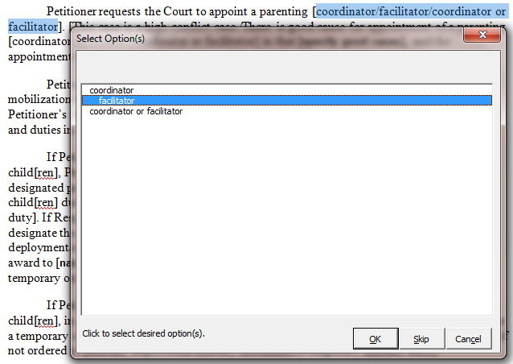

To complete a Select Option(s) fill-in:

When the Next [Fill-in] tool stops at the fill-in, the bracketed text is displayed in a list in the Select Option(s) dialog box.

Select the desired option(s).

Click on an option to select it.

Click an option again to deselect it.

Choose OK.
The Fill-in is replaced by the selected text.

Caution:
If you selected multiple options from the list, they will be separated by a space. If different punctuation is appropriate, make the change directly in the document.

Complex Fill-Ins
Some bracketed sets of text include both slashes and sublevel bracketed fill-ins and may require a combination of choosing an option and replacing text. The text for these fill-ins will be presented to you in a Keep/Discard dialog box where you can replace the entire prompt with the desired text.
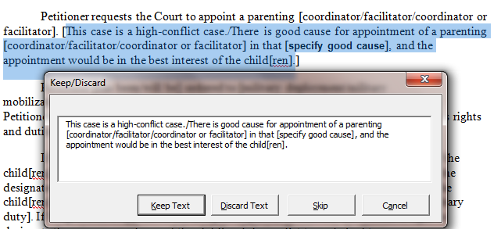

To complete a Complex Fill-In:

When the Next [Fill-in] tool stops at the fill-in, the bracketed text is displayed in a Keep/Discard dialog box.

Modify the text to say exactly what you want it to say in the document.

Choose Keep Text.
The bracketed text in the document is replaced with what you choose.

Note:
If you find it easier, you can choose Skip or Cancel and then edit the fill-in text directly in the document.

Skipping Fill-Ins
Sometimes you may want to temporarily skip a fill-in and come back to it later. When a replacement fill-in is selected, you can click Next [Fill-in] to leave it as is and move to the next fill-in. When presented with a dialog box, you can choose the Skip button to leave the current fill in intact and move past it.
Later, as long as your insertion point is in front of the fill-in, choosing Next [Fill-in] will navigate you through the remaining sets of bracketed text.

Navigating Colons
Throughout the forms you will encounter text followed by a colon where you need to add information (such as “name:”). This is not part of the bracketed fill-in text, but you will want to make sure you do not miss any of these colons. Use Word’s Find feature to visit each colon in the document.

To visit each colon in a document:

Press Ctrl+Home.
The insertion point moves to the very beginning of the document.

Choose Find from the Editing group on the Home tab.
–OR–
Press Ctrl+F.
The Find and Replace dialog box opens to the Find page.
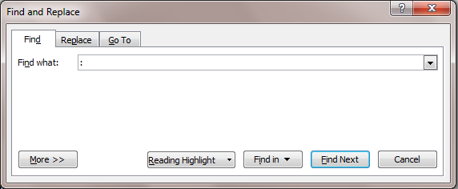

Type a colon in the Find what text box.

Choose Find Next.
The next colon in the document is selected.

If necessary, click in the document and then type the text to follow the colon.

Continue to use the Find and Replace dialog box to navigate by colons.
–OR–
Close the dialog box and then press Ctrl+PageDown on the keyboard to move from colon to colon in the document.

Clause Selector
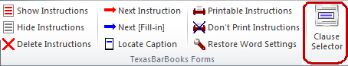
When clicked, the Clause Selector button launches the Clause Selector tool, which is designed to help you browse, select, and copy individual clauses from forms that are collections of clauses, to prevent your having to manually navigate through sometimes lengthy documents to find the clause you want.
The Clause Selector tool allows you to browse clauses by title or by number and to review the clause text and clause-specific instructions:
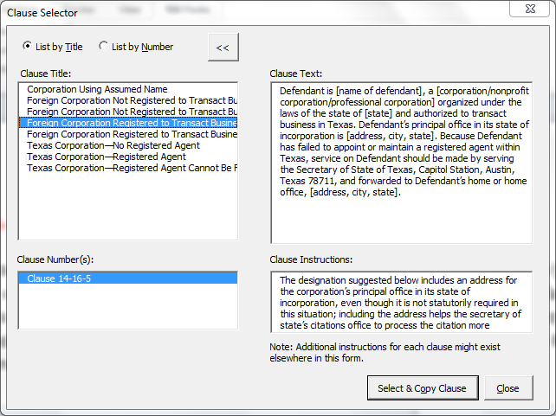
After you find the desired clause, click the Select & Copy Clause button, and the clause number, text, and clause-specific instructions will be copied to your clipboard for pasting into other documents.

Using TBB Forms
Most of the tools on the TBB Forms toolbox were developed specifically to work with content in the TBB Forms. Their behavior in other documents is unpredictable, so they have be set to ensure that they are being used in a TBB form. If you try to use them in a non-TBB document, you will see the following alert message:
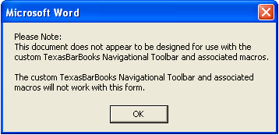
If you see this alert message but believe the document you’re working on is a TBB form, it’s possible you’ve run a metadata stripping utility that removed the document variables that identify the form. Try again in a fresh copy of the form. If the fresh copy works, you can copy your edited form and paste its text into the fresh copy.
Similarly, the Clause Selector tool was developed specifically to work with content of TBB Forms that are collections of clauses. If you try to use the Clause Selector tool in a document other than a TBB collection of clauses, you will receive an alert message informing you of that fact.

