Preparing Word Forms for E-Filing (Windows*)
To remove personal information, hidden text, and other metadata before filing or sharing a document electronically, launch Word’s “Inspect Document” tool.
- 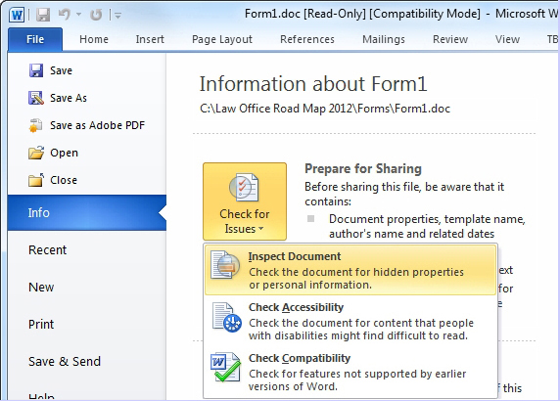Go to File | Info | Check for Issues | Inspect Document (Alt + F + I + I + I).
- 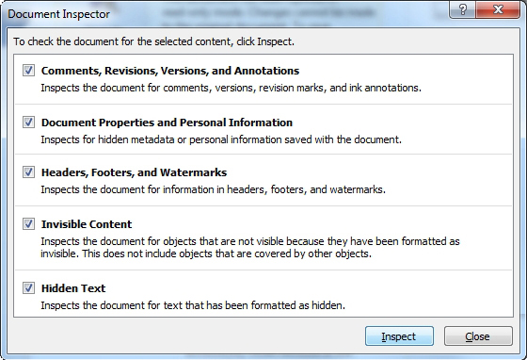In the “Document Inspector” window that opens, select the categories desired by checking the appropriate boxes (be certain to check the “Hidden Text” box to ensure that any remaining red, hidden instructional text in the document will be also be detected) and click the “Inspect” button.
- 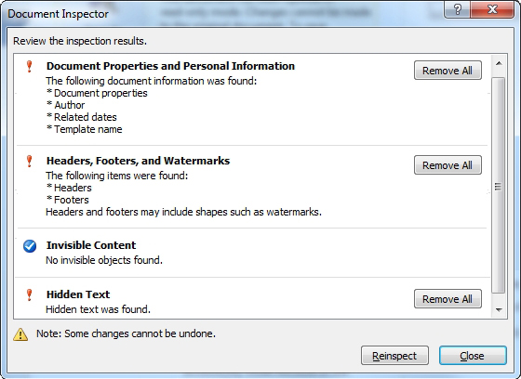In the second “Document Inspector” window that opens, review and remove any metadata found as desired.
CAVEAT: Although the above steps should remove basic metadata and the form instructions from the Word forms, electronic files contain all manner of metadata. It’s wise to familiarize yourself with the types of data stored by any software you use in the types of files you plan to share and reasonable measures available to remove that data before sharing.

